Chapter 4

Review of Standards for Information Exchange

Introduction

The need for data exchange has been a requirement since the first applications of CAD/CAM systems. It has historically and continues to be a process of evolution. This chapter describes the evolution of standards for data exchange for engineering systems. Section 4.2 introduces the various methods for information exchange, Section 4.3 describes early efforts for standardization, Section 4.4 describes the STEP Standard and major entities that form the structure and concepts relating to the standard. The final part of the chapter outlines in more detail the application protocols related to the author’s research.

The Methods for Data Exchange

The advent of Computer Aided Design (CAD) tools represented an impressive gain in productivity over the use of the paper drawings. Not only because CAD tools made it easy to edit and store engineering data as never before but they also enabled the use of information directly from design to manufacturing tools (Goldstein et al. 1998). As fast as new CAD and Computer Aided Manufacture (CAM) tools were created the number of formats to represent and store product data increased as well. This was and is still a problem to companies, which need to share this data between different tools either in their own process or with a partner in the supply chain. This problem was perceived in the early beginning of CAD/CAM systems where two major methods were recognised to solve the problem (Zeid 1991). The first is called direct translation that implies the development of a pair of translators to exchange data between each pair of systems. The other solution is the indirect translation of data using an intermediary file also called a neutral file. The use of a neutral file format implies that each application needs a pair of translators, one to write in, and other to read from the neutral file format. This is a vendor’s independent format and its structure is also independent of any existent system (Zeid 1991).
The advantages of direct translation are the small size of the generated files and speed as it is a one-stage solution, and in addition for a specialised company the loss in semantic data is usually low or none. The major drawback is when the number of CAx systems involved increases, the number is so high that many different translators are required and the solution becomes very expensive. Figure 4.1(a) shows the direct translation solution and figure 4.1(b) shows the neutral file strategy solution. The equation 4.1 shows the number of translators needed when there are more than 3 systems involved using direct translators and equation 4.2 is the number of translators needed when using indirect translators (Kern 1997, Zeid 1991).

N= n x (n-1)  N= n x 2 | (4.1)  (4.2)
Where:
N = number of translators.
n = number of systems.

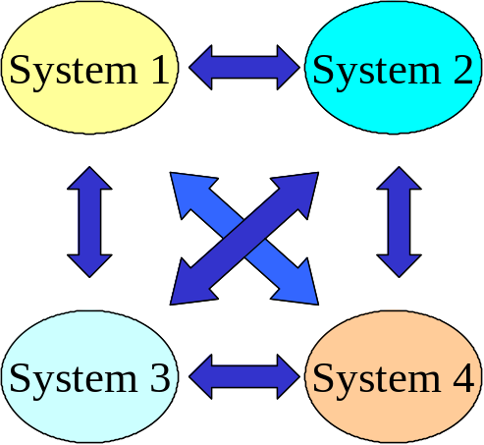 | 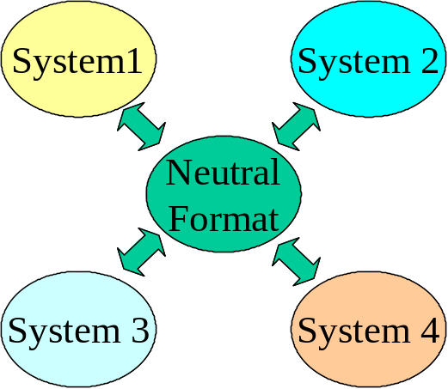
(a) Data exchange using direct translators. | (b) Data exchange using Neutral File.
Figure 4.1 – The ways for data exchange (Adapted from Zeid (1991))

Kern (1997) highlights the advantages of using neutral files as it is necessary to only have two translators for each CAx system involved, independence of supplier, possible use in archiving which protects the user against obsolescence as it is not technology dependent. The author also can say that the cost of development tends to be lower than the cost of direct translators as a consequence of the number of programs necessary when the number of systems grows.

The main disadvantage of neutral files detected by the author is the large size of these files that are normally larger than those obtained in direct translation. A further concern is the loss of information that can occur due to the non-existence of corresponding entities in one of the systems involved.

Early Standards for Design and Manufacture

The efforts to create a neutral data exchange format began in the 1970’s with the contribution of X3/SPARC Committee of the American National Standard Institute (ANSI) in the United States. It proposed a three layer methodology that gives different views of the same information entitled conceptual, internal and external views. This methodology was used by the Integrated Computer Aided Manufacture (ICAM) program to develop the formal methods for information modelling named IDEF0 (ICAM Definition Level 0) later proposed as a Standard by NIST (NIST 1993a), IDEF1 later named IDEF1X (NIST 1993b) and IDEF2 (Kemmerer 1999). The ICAM program and its subsequent contracts such as the Product Definition Data Interface (PDDI) and Geometric Modelling Application (GMAP) (Goldstein et al. 1998) programs influenced the future development of STEP (Goldstein et al. 1998, Kemmerer 1999).

The ICAM program also influenced the birth of the Initial Graphics Exchange Specification (IGES) at the end of the 1970’s. This effort to create IGES was an initiative of the US government, CAD/CAM users and vendors. They worked in a committee co-ordinated by the National Bureau of Standards (now the National Institute of Standards Technology-NIST) which generated the first release of IGES in 1980 (Kemmerer 1999). This standard achieved relative success but suffers from some problems that are difficult to solve mainly because of its conception for geometrical and topological representation that was inadequate to represent a product throughout its life cycle. IGES does not have a formal model; there are a number of specific interpretations by the vendors which lead to translations being incomplete or containing errors. IGES uses an 80-column format that is difficult for human reading (Bhandarkar et al. 2000), also the file size and processing time are very large. In order to solve these problems many efforts were made to develop an International Standard. Other contributions in the effort to develop a standard for a data exchange format have been undertaken by the European Association of Aerospace Industries that have developed a format to exchange simple surfaces. This was not extensively used but the United Kingdom generated the AECMA Report of the Geometry Data Exchange Study Group to the International Organization for Standardization (ISO) that provided a useful contribution to today’s STEP Standards.

In 1982, the first release of the German Standards VDA (Flachenschnittstelle Des Verbanes der Deutschen Automobilindustrie) for the automotive industry was issued, which addressed the issue of data exchange for free form surfaces and free form curves (VDA-FS) and subsets of annotation entities (VDA-IS). The VDA-FS was a contribution from Germany to the development of STEP. The French contribution comes from SET (Standard D’Exchange et de Transfert) a project of Aerospatiale to bypass some problems of IGES translations. It added detailed specifications to the mechanical area, supplementary information about data structures and concepts employed, together with rules and recommendations concerning specifications to ensure coherence in future developments (Zeid 1991).

In 1984, a project called CAD Interfaces (CAD*I), funded as an ESPRIT project by the European Commission, focused on product model data exchange and on a data exchange for finite elements analysis. CAD*I used schemas based on a modelling language with much of the shape modelling capability of today’s STEP standard coming from CAD*I project (Kemmerer 1999). In the same year during a meeting of the IGES Organization Edit Committee, the effort for the first Product Data Exchange Specification (PDES) began. PDES was proposed by the United States to ISO TC 184/SC4 (Technical Committee 184/Subcommittee 4) and has become the basis to what today is known as STEP.

As can be observed, STEP is a result of the efforts of many organizations in the attempt to develop a method for data exchange and later, data sharing. In the following section the standard is described, as it is the basis for the STEP-NC, which is one of the main subject areas of this research.

The STEP Standard Concepts and Structure

The set of documents that forms the ISO 10303-series standard is commonly called STEP this is an acronym for the STandard for the Exchange of Product data model. As seen in the previous section, STEP is the result of the experience gained by the community of users and developers of standards through the initial efforts standards for standardising data exchange. The concept of STEP is that it can be used for data exchange and sharing of product information (Fowler 1995). The objective of this standard is to provide a mechanism to describe the product data throughout the complete life cycle (Rahimifard and Newman 1996). An important aspect of STEP is its extensibility, which was one of the initial objectives in the beginning of its creation (Kemmerer 1999). The extensibility is achieved through the use a formal language for modelling data (Loffredo 2000). According to Ashworth and colleagues (1996), among the aims of STEP are completeness and correctness, minimality, understandability, manageability, maintainability and upward compatibility. This is achieved using the strong concept of formal languages, which is applied using the EXPRESS language. This was also the way used to avoid ambiguities in the representation of product data models. As Fowler (1995) points out, one of the key differences between STEP and other standards is the independence of data models defined in the standard and the various ways to implement them.

Structure of the Standard

STEP was structured to be able to describe products of various domains and to test if the applications built using the standardised methods are really adherent, or not, to the ISO 10303 standard.

The structure of this Standard is described in ISO 10303 Part 1 (ISO10303–1 1994) as below:
- Description Methods : Parts 11 to 19
- Integrated Resources that are divided in:
- Generic Resources: Parts 41 to 99
- Application Resources: Parts 101 to 199
- Implementation Methods: Parts 21 to 29
- Conformance Testing and Methodology: Parts 31 to 39
- Application Protocols: Parts 201 to 1199
- Abstract Tests Suites : Parts 1201 to 2199

Although, Loffredo(2000) shows this in a more high level structure, which divides the Standard into two parts, namely Infrastructure and Information models as depicted in figure 4.2. The following sections describe the mentioned parts and their functions in the standard.
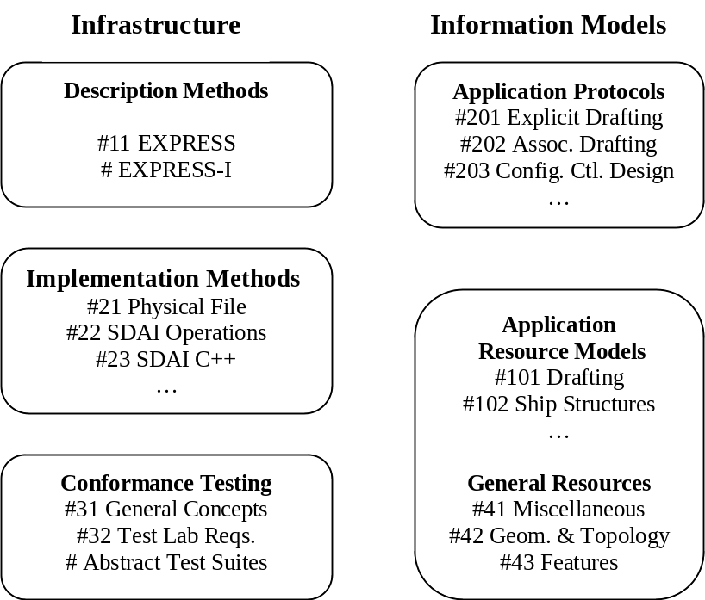

Figure 4.2 – The High Level Structure of STEP (Loffredo 2000)

Description Methods

These methods are based on the idea that the description of product data should not be ambiguous, and the best way to avoid ambiguities is through the use of a Formal Data Specification Language. In order to describe a product using integrated resources and application protocols, the EXPRESS language and graphical presentation of models are used that will be described in section 4.5 (ISO-10303-1 1994).

This part of the STEP Standard (so called 10’s Series) comprises of documents relating to languages, which represent product data in a standard form. The fundamental description method of STEP the EXPRESS Language is described in this series (Kern 1997).

Integrated Resources

There are two groups of integrated resources namely the generic and application resources. They comprise of the series 40 and 100 respectively. They are used to describe products using EXPRESS. The generic group are independent resources and can reference each other, the application resources however, cannot reference each other (ISO10303-1 1994). Ashworth et al. (1996) emphasises the key role of these resources. The generic resources provide a flexible means to create integration across different applications, where integrated resources roughly act as building blocks for many other parts of STEP.

Application Protocols

This is the part of the STEP Standard that specifies an Application Interpreted Model (AIM). These models satisfy the scope and information requirements for each application (ISO10303-1 1994). Each AP(Application Protocol) is specific to a particular engineering domain. Application protocols like information models describe the data structures and constraints for a product model (Loffredo, 2000). In fact, the idea of AP’s comes from the experiences learned in the IGES/PDES development group (Goldstein et al. 1998, Kern 1997). A description of the main application protocols related to this research are provided in section 4.6.

Implementation Methods

This part of the standard specifies a technique used by computer systems to exchange product data that is described using the EXPRESS language (ISO10303-1 1994). Implementation methods in STEP are also called 20’s series. Its function is the mapping of formal specifications to a representation using formal methods used in STEP (Nell 2000). At the time of the writing of this work the following parts have been released(ISO 2004):
- Part 21 - clear text encoding that is used to write exchange files.
- Part 22 - standard data access interface (SDAI).
- Part 23 - C++ language binding to the standard data access interface.
- Part 24 - C language binding of standard data access interface.
- Part 27 - Java TM programming language binding to the standard data access
interface with Internet/Intranet extensions(ISO/TS10303-27 2000).
- Part 28 - XML representations of EXPRESS schemas and data(ISO/TS10303-28 2002).

Particular attention should be given to part 21 which is heavily utilised as it is used to represent the format of most of the interchange files. The last two parts 27 and 28 are currently receiving significant attention of many research groups due to the increased applications on the Internet(Xu and Mao 2004, Proctor et al. 2002, Burkett 2001, Ma et al. 2001, Lee et al. 2003).

Conformance Tools

One of the remarkable features of the STEP standard is the provision of a framework of conformance tests. The conformance tests are developed for each AP and are specified in a abstract test suite (ISO10303-1 1994). The STEP standard places a very high emphasis on tests and is probably unique to place conformance test as part of the standard (Nell 2000). This was one of the major failure points in the former standards such as IGES, SET and VDA (Kern 1997), and was an “open door” for each vendor to design its applications using specific interpretations. The ISO TC 184/SC4 (Technical Committee 184/ Subcommittee 4) committee included the conformance tests from the experience of ISO 9646, the conformance tests methodology for the OSI (Open Systems Interconnection) protocols (Fowler 1995, Kemmerer 1999).

AAM - Application Activity Model

An Application Activity Model (AAM) is a type of model used in the STEP standard to describe an application in terms of its process and information flows (ISO10303-1 1994). It is a graphical model, which depicts the industries activities that supports each AP. A mapping table is used to describe how the information requirements are satisfied (Borja 1997). Figure 4.3 depicts the basic notation of an Application Activity Model in IDEF0 according to the NIST document (NIST 1993a).
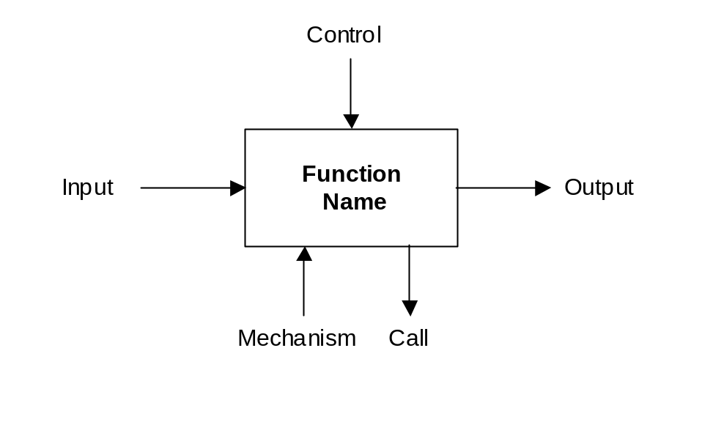
Figure 4.3 – The basic notation of AAM based on IDEF0(NIST 1993a).

ARM - Application Reference Model

In ISO 10303 Part 1, an Application Reference Model is defined as “an Information Model that describes the information requirements and constraints of a specific application context.” (ISO10303-1 1994)

This means that for a given AP an Information Model called ARM should be defined. The ARM is a graphical model of entities and relationships that specifies data for an Application Protocol (Borja 1997). The information of a process identified in an AAM must be defined in the ARM representation. The way to define graphically the information in an ARM form is using IDEF0, IDEF1X, NIAM (Nijssem Information Analysis Methodology) information modelling and EXPRESS-G (ISO10303-1 1994, Kern 1997).

AIM - Application Interpreted Model

An AIM is an information model that describes data with names and structures using STEP terminology. It contains the STEP standard names and structures for the data in a given AP and represents the product data to be shared in a data exchange environment in terms of the STEP standard (PDES 1997). It uses a mapping table to describe how the information requirements (ARM) are satisfied (Borja 1997). The AIM is “an information model that uses the integrated resources necessary to satisfy the information requirements and constraints of an application reference model, within an application protocol to be present in a conforming implementation” (ISO10303-1 1994).

AIC – Application Integrated Constructs

Also called the 500’s series the Application Integrated Constructs (AIC) are reusable groups of information-resources entities and aim to provide interoperability between AP’s. (Kern 1997, Nell 2000). It provides a logical grouping of interpreted constructs to support specific functionality (ISO10303-504 1999). When multiple AP’s are in use it is very useful and desirable that information may be shared, an AIC makes it possible to express identical semantics in many application protocols. The concept of reusability that is common in object oriented systems development is used here. This does not mean that an AIC must contain objects as in the meaning used in object-oriented programming but it is object flavoured.

The EXPRESS Language

The EXPRESS Language is a Formal Data Specification Language defined in the Part 11 of the STEP Standard (ISO10303-1 1994, ISO10303-11 1994). According to Kemmerer (1999) it was designed as a language for communicating information that it has much in common with database definition languages and programming languages but unlike these:

“…EXPRESS does not confuse the information task with programming or database tasks and it is not specific to a particular programming or database system.” (Kemmerer 1999)

In fact EXPRESS is neither a programming language nor a database language. The aim of EXPRESS is to describe the characteristics of information that might exist in an information base (Kern 1997). It uses the Syntax Wirth Notation(SWN), that is based on BNF (Backus-Naur Form) (Wirth 1977) as a basis of the STEP file structure (Kern 1997). The physical file used for exchange of data is defined in Part 21 (ISO10303-21 1994) of the STEP standard and uses EXPRESS to describe the product data. Actually, EXPRESS is the keystone of the STEP standard.
  - The standards related to ISO 14649

Within the STEP Compliant approach to program CNC machine tools, the main idea is to share the information about the existing features (see the features concept in Chapter 3) for a mechanical part (ISG 2000b). The application protocol 203 is used to share the general data related to geometry and identification of the part. AP 224 is used to define all the part features, in the early stages of development of ISO14649, AP 213 was thought to support the definition of process planning that splits the features from AP 224 into sets of processes such as milling, turning, grinding and inspection (Step-NC 2000b). However, during the development of this work AP 213 was withdrawn from the development scene and superseded by AP 240. In the case of inspection the use of AP 219 is also being developed (Step-NC 2000b).

The following sections explain the most important protocols used in the research work. These are related to the CAD/CAPP/CAM CNC process chain, namely: AP 203, AP 224, AP 240, AP 219, and AP238

    - AP 203 - Application Protocol: Configuration Controlled 3D Designs of Mechanical Piece Parts and Assemblies

This AP is well established and has a well-defined scope as cited below:

“This part of ISO 10303 specifies the integrated resources necessary for the scope and information requirements for the exchange between application systems of configuration-controlled 3D designs of mechanical parts and assemblies. Configuration in this context only includes data and processes that control the 3D product design data. Exchange is used as a scoping consideration to narrow the scope to only those data, which are exchanged as part of the 3D product definition. Organisations exchanging data within the scope of this part of ISO 10303 may have a contractual relationship, the details of which are outside the scope of this part” (PDES 1998, ISO10303-203 1994).

This means that AP203 specifies the exchange of data for mechanical products only. Its aim is to exchange data about the initial phase of the product life cycle while the product is in the design phase. In this specification the 3D shape of a part or assembly may be made by five different types of geometric representation which are: wireframe and surface geometry without topology, wireframe geometry with topology, manifold surfaces with topology, boundary representation and faceted boundary representation (see section 3.2.). These types are also called conformance classes (PDES 1998). The Application Interpreted Model (AIM) is outlined in section 5 of AP 203 where it is identifiable that most of the entities have as source the Parts 41, 43 and 44 of STEP known as the Integrated Generic Resources (see Section 4.4.3), which are shared between other APs. It should be noticed that AP 203 is one of the most used parts of STEP as it is used to import and export files to provide geometric data for a number of CAD and CAM systems.

However the importance of shape exchange, many parts of the AP 203 are dedicated to specify data, which controls the tracking/flow and management of the product. This data includes (ISO10303-203 1994):
- the identification of a product to an organisation’s customers and the link of design identification of components;
- documentation of changes and releases of designs;
- the history of the product,
- the structure and relationship of each component of the product to the whole product;
- information concerning materials processes finishes and other design requirements; and
- identification of qualified suppliers for the product or its design.

STEP uses three basic AIM entities to define a part in AP 203. These are the product entity, which establishes the identification of a part (or part number), name of a part (or nomenclature), and description. The product_definition_formation_with_ specified_source, this entity identifies its version (or change level) and the product_definition or product_definition_with_associated_documents, which identifies the engineering discipline view that all the data related to it represents. The figure 4.4 depicts graphically the relationships among these entities that define a part using AP 203. This approach permits the representation of data at a high level of abstraction and the sharing of this data throughout all industry (PDES 1998).

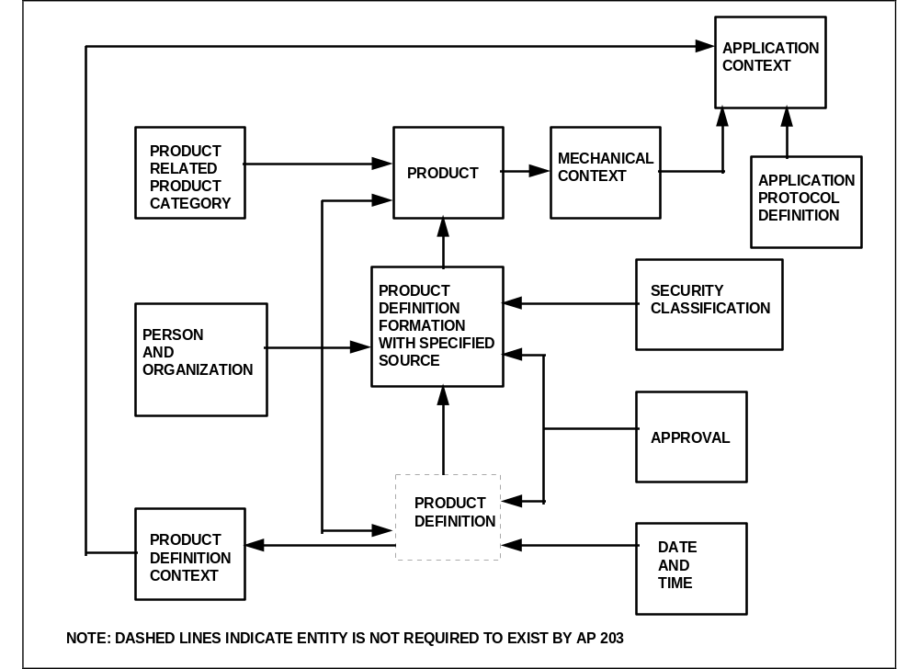
Figure 4.4 – The relationships among the entities needed to define
a part in AP 203 at a high level. (PDES 1998).

    - Part 224 - Application Protocol: Mechanical Product Definition for Process Planning Using Machining Features

AP 224 is the part of STEP that specifies the representation of information needed to define a single piece mechanical part for process planning purposes (ISO10303-224 2000). The AP 224 was planned to support design and manufacturing and minimise rework, it ensures the right product is made first time (ISG 2000a). This is possible because AP 224 identifies specific characteristics of part shapes used in manufacturing. These are represented by machining features or solid models in boundary representation that may be shared by other AP’s and used as an application interpreted construct (AIC) in AP 224 (ISO10303-224 2000).

AP 224 provides the geometry of the part and also the part’s features, dimensions and tolerances, material requirements, and notational information. In other words, everything a manufacturer needs to know to efficiently produce the right part the first time(SCRA 2004).

The AP 224 scope is (SCRA 2000):

- Single mechanical part manufactured by machining processes,
- Parts manufactured by either milling or turning processes,
- Shapes necessary for manufacturing are defined by features,
- 3D explicit shape representation,
- Implicit feature definitions through use of parameters,
- Machining feature constructs,
- Additional part information,
- Orders,
- Customer order, work order,
- Approvals and authorisations to manufacture a part,
- Requisitions of raw stock for documenting manufacturing history; and
- Design exception notice.

A set of information requirements (IR) are defined in section 4 of AP 224, and most of this section defines details of manufacturing features. The Information Activities Model (AAM) aids to understand this scope and the IR of the protocol using a modified IDEF0 notation as in the figure 4.5 that depicts a mechanical product definition using machining features (ISO10303-224). The 2nd edition of the standard was released in May 2001 with interesting improvements such as new feature types, manufacturing assemblies and harmonization with AP 214(ISG 2000b).

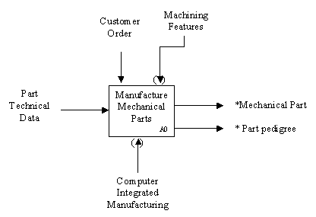

Figure 4.5 – IDEF0 A0 for mechanical products definition for process planning using features. The * indicates Input, Output, Control, Mechanism (ICOM) and activities out of scope (ISO10303-224 2000)

    - Part 240 - Application protocol: Process Plans for machined Products

During the period of this research work AP 240 replaced AP 213, the standard initially written to be used in process planning for Numerical Controlled machines. AP 240 is however, broader in scope as it is also suitable to use in manual operations. According to the current version of the evolving AP 240 standard the following represents its scope (ISO10303-240 2003):

- information out of the planning activity that is contained in the process plans for machined parts which includes: numerical controlled machines and manual operations.
- the manufacture of a single piece mechanical part, and assemblies of single piece parts for manufacturing purpose which includes: process data for part routing which includes manufacturing process and set-up sequencing and process data for operations.
- interface for capturing technical data out of the upstream application protocols which includes: product definition data, including tracking a design exception notice of a part and the initial material definition data.
- technical data for and/or out of the process planning for machined parts which includes: machining features for defining shapes necessary for manufacturing, machining feature classification structure, geometric and dimensional tolerances of the parts being manufactured, materials and properties of the parts being manufactured.
- references to standards and specifications declared in the process plan;
- work instructions for the tasks required to manufacture a part, using which include: references to the resources required to perform the work, the sequences of the work instructions and the relationships of the work to the part geometry.
- information required to support NC programming of processes specified in the process plan.
- information required to support in-process inspection specified in the process plan.
- shop floor information specified in the process plan.
- information for production planning specified in the process plan.

Thus, AP 240 covers a wide range of needs in terms of representation of information related to the process planning activity. According to AP 240 (ISO10303-240 2003), a process plan is a set of instructions which are used by programmers to create NC programs to drive the tool motion to remove material.

AP 240 specifies the data contained within a process plan but not the data necessary to perform process planning. Included in AP 240 are the relationships that exist between the different process plan data items and the relationships between these data items and the product definition data. The product definition data includes data items from the design process such as geometry, surface finish and machining tolerance(ISO10303-240 2003).

In this research work, the author has identified that some parts of the AP240 structure can be utilised to represent the data that is necessary to perform the process planning. Thus, parts such as the manufacturing_machine_tool_resources and its application objects have been used to represent manufacturing resources (this will be explained in chapter 7). The use of standard entities defined within the STEP standard should improve the interoperability of the manufacturing model.

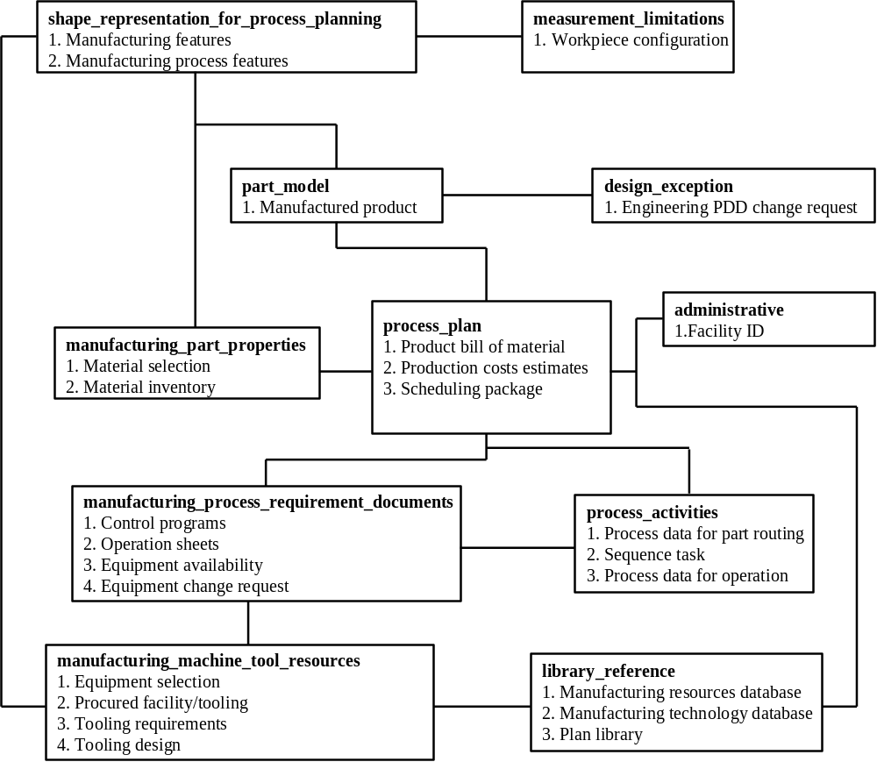
Figure 4.6 – Process Planning Data Planning Model (ISO10303-240 2003)

    - AP 219 – Dimensional Inspection Planning

This protocol manages the dimensional inspection of solid parts or assemblies and was the Proposed Work Item (PWI) submitted in June/1998 to the ISO/TC184 committee. During the writing of this thesis the AP 219 was still under development as a Committee Draft(CD). The AP specifies information requirements to manage dimensional inspection of solid parts or assemblies, which includes: administering, planning, and executing dimensional inspection as well as analysing and archiving the results. In its scope the dimensional inspection can occur at any stage of the life cycle of a product where checking for conformance with a design specification is required (ISG 2000b). It is out of the scope of AP219 (ISO/CD10303-219 2002):
- Developing or modifying manufacturing process information,
- Generating geometry (creating the CAD model),
- Generating tolerance requirements, and
- Inspection of material properties.

An important amount of entities used within this AP are based on AP 224 entities. Most of the manufacturing features and tolerance definitions are actually references to AP 224 entities. This means that a high level of integration has been achieved so far in the development of this standard.

It is important to note two of the units of functionality, namely: Dimensional_ measurement_features , in which Dm_Feature is the base class for the features related to measurement, and the unit of functionality measurement_limitations which contains the information needed to identify important dimensions and relationships between them and the part’s shape. In measurement_limitation are included the tolerances and many types of datum.

4.6.5 AP 238 - Application Interpreted Model for Computerized Numerical Controllers

This AP is the Application Interpreted Model (AIM) of the ISO 14649 Standard, which is the Application Reference Model (ARM) (see sections 4.4.8 and 4.4.9). AP 238 specifies the integrated resources used to describe the information requirements identified by ISO 14649(ISO 10303-238 2004). It is claimed that it is “in manner consistent with the part shape, feature, and geometric tolerance information created by design and process planning activities and represented by APs 203, 214, 224 and 240” (ISO 10303-238 2004). Feeney at al. (2003) say that the primary difference between ISO 14649 and ISO 10303-238 is the degree to which they use the STEP representation methods and technical architecture. They also explain that the standard uses the EXPRESS models in ISO14649 “with a few modifications” (Feeney at al. 2003) then maps it into the STEP integrated resources.

The scope of AP 238 is described as being (ISO 10303-238 2004):

- mechanical parts for manufacturing
- manufacturing process descriptions, including manufacturing operations, sequences of operations, and associated information as defined in ISO 14649
- the AS-IS and TO-BE shapes of a mechanical part
- manufacturing features of a part
- manufacturing tolerance requirements of a part
- tool requirements for machining operations
- tool paths for machining operations
- manufacture of mechanical products using manufacturing processes defined in ISO 14649
- manufacturing product discipline view

AIM is used to provide a way to share application information through databases that implement ISO 10303 generic resources without needing to modify the structure of the database (ISO 14649-1 2002).

From the analysis of the files generated by ISO10303-238 and from ISO14649 it can be said that the AP 238 is a more verbose way to describe the same NC program. Therefore, AP238 should fit better together other parts of STEP. A discussion over the advantages and disadvantages of the two standards can be found in Feeney at al. (2003) and Wolf (2003).

During most of the development of the research described in this thesis AP 238 had only the milling model and the DIS version with the turning capabilities becoming available during the writing up of this thesis. Thus, the ARM (ISO 14649) was used to develop the models described in Chapter 7.

  - Review Summary

Since the early CAD and CAM systems were developed the search for efficient data exchange has been a priority. With the wide range of vendor specific bespoke translators the research community has put enormous efforts into STEP standards to provide an encompassing solution.

Though these efforts have enabled vendors to generate STEP translators, their use has only given limited success. A major stumbling block has been the links from CAD to CNC, due to limited programming capabilities and the closed nature of CNC controllers. This has meant that STEP has only been used as a CAD to CAM translator with little or no data transfer for process planning or manufacturing knowledge. Over the last 6 years, but more specifically from 2002 significant efforts have been made in the STEP community to close the design to manufacturing divide, which the author believes will empower the existing STEP standards. These new developments termed STEP Compliant Manufacturing are outlined in Chapter 5.

